MLA style requires that your paper use a “Times New Roman” 12 point font and double spacing and one inch margins. For specific needs, see Purdue’s On-Line Center at https://owl.english.purdue.edu/owl/resource/747/01/

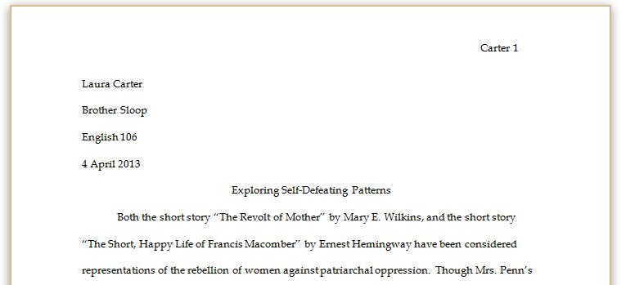
Header
Every page should a header that is right-aligned and includes your last name and the page number.

MLA does not normally have a title page. However, in the upper left-hand corner of the first page, you should list your name, the professor’s name, the class, and the date (with the date formatted like 19 November 2013).

In-Text Citations

Every time you use another author’s ideas, do the following
- In parentheses after the quote, put the last name of the author and the number of the page.
- Put the period outside the parenthesis.
- If there’s no author, use the title of the article instead. If there’s no page, omit it.

You can also divide the citation by mentioning the author’s name when introducing the quote. Then just put the page number at the end.

Full citation | However, such situations cause “permanent trauma to the formation of the brain” (Hunt 42).
Divided citation | In Thomas A. Maik’s article, he states, “Women in marriage have prescribed roles” (25).
No page | This form of manipulation is present in a surprising 90% of marriages (Miles, Barn, and Phillips).
No author or page | These stories represent “the rebellion of women against patriarchal oppression” (“Existentialism”).

Block Quotations
If you use a quote that is four lines or more, make the quote its own paragraph. Indent the entire paragraph one inch from the left margin, omit the quote marks, keep it double spaced, and put the citation after the final period.

…even though user-linked content has increased with convenient sharing mediums, as stated by Marissa Adler:
For a while, the only problem with del.icio.us was a dearth of user participation: Who could be bothered to go to a web form and put in their bookmarks? The latest Firefox del.icio.us extension (and there have been many) is the smoothest yet: It puts the link to visit del.icio.us and the link to tag a page on a convenient toolbar that sits next to the Forward and Back buttons at the top of the browser. This raises del.icio.us bookmarking to the navigation level, where it belongs. (23-4)

Headings
You will normally only use Level 1 headings to mark different sections. However, you can also create subsections for a Level 1 heading by using Level 2. Level 3 creates subsections for a Level 2. Never add space before or after headings.

Level 1: Bold, left-aligned, begin text on next line | Literary Movements
Level 2: Italicized, left-aligned, begin text on next line |  | The Postmodern Age
Level 3: Bold, centered, begin text on next line | Postmodern Writer, Paul Auster

Works Cited Page
The References page starts the last page of your document. Keep it double spaced with no extra space between entries. Create a hanging indent (see “Working with Word” handout), and alphabetize by the first word of the reference entry.

“Works Cited” is centered  and unformatted | Works Cited
Web page with an organization as the author | CDC. “Marriage and Divorce.” FastStats. Centers for Disease Control and Prevention, 24 Apr. 2013. Web. 21 Nov. 2013
Web page with no date | Diersman, Angie. “How to Make Creative Hardware Menorahs.” eHow. Demand Media, n.d. Web. 21 Nov. 2013.
Web page with no author | “Existentialism.” The Literature Network. Jalic, n.d. Web. 21 Nov. 2013.
Web page with unconventional author  and no publisher | GinnyKnows. “Five Behaviors You Didn’t Know You Did.” Marriage Meows. N.p., 12 May 2006. Web. 21 Nov. 2013.
Print copy of book | Hemingway, Earnest Miller. For Whom the Bell Tolls. New York: Harper Collins, 1936. Print.
Dictionary entry | “hysteric, adj. and n.” Oxford English dictionary. Oxford University Press, n.d. Web. 21 Nov. 2013.
Scholarly journal with  two authors | Moik, Albus, and Thomas Farnsworth. “Reclaiming Paradise: Role Reversal as Liberation in Sarah Orne Jewett’s ‘Tom’s Husband.’” Legacy 7.1 (Spring 1990): 23-9. JSTOR. Web. 21 Nov. 2013.
Scholarly journal with more than three authors | Pike, Leonardo Eldon, et al. “Role Change.” Annual Review of Sociology, 16 (1990): 87-110. EBSCO. Web. 21 Nov. 2013.
Selection from anthology with editor and later edition | Roethke, Theodore. “Root Cellar.” The Bedford Introduction to Literature. 2nd ed. Ed. Michael Meyer. Boston: Bedford Books, 1990. 548-549. Print.
Newspaper article  from web | Rosenberg, Tina. “To Fight Obesity, a Carrot, and a Stick.” The New York Times 16 Nov. 2013: SR7. Google News. Web. 21 Nov. 2013.
Note: Although MLA does not ask for URLS, it does require a date and publisher for websites. The publisher may be found by scrolling to the bottom of the webpage and seeing the name next to the copyright date. If there is no publisher, put “n.p.” If there is no date, put “n.d.”

