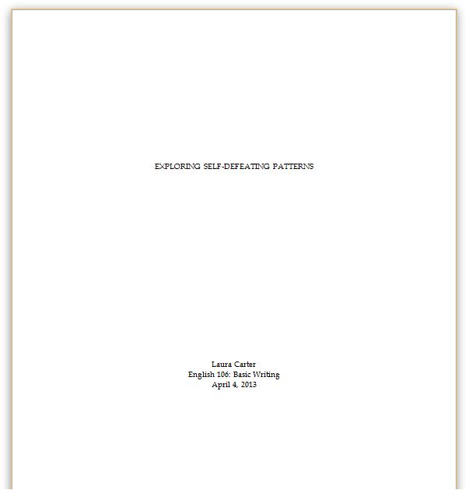
These styles require that you use a Times New Roman 12 point font, double spacing and one inch margins.
For specific needs, see Purdue’s On-Line Center at https://owl.english.purdue.edu/owl/resource/717/01/

Title Page
To create a title page, do the following:
- Center all text
- Put the title in all caps a third of the way down the page (just eyeball it—there’s no science to it)
- Two-thirds of the way down the page, put your name, the class, and the date (i.e. November 26, 2013)

The next page will have no title. Just create a header that has the page number right-aligned. Set this page as number one by going to the “Header Design” tab, selecting “Page Number,” “Format Page Numbers” and entering “0” under “Start at.” Use this header throughout the rest of the paper.

In-Text Citation: Footnotes and Endnotes
Your professor will request you use either footnotes or endnotes. To cite something, put your cursor after the final punctuation of the cited material. Then (if working in Word), click either “Insert Footnote” or “Insert Endnote” under the
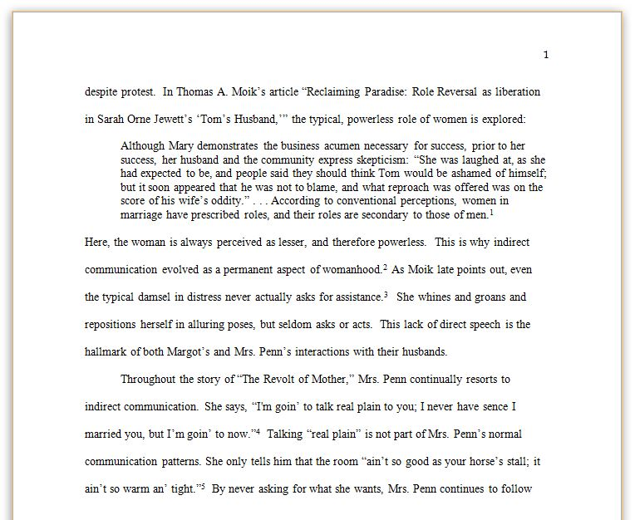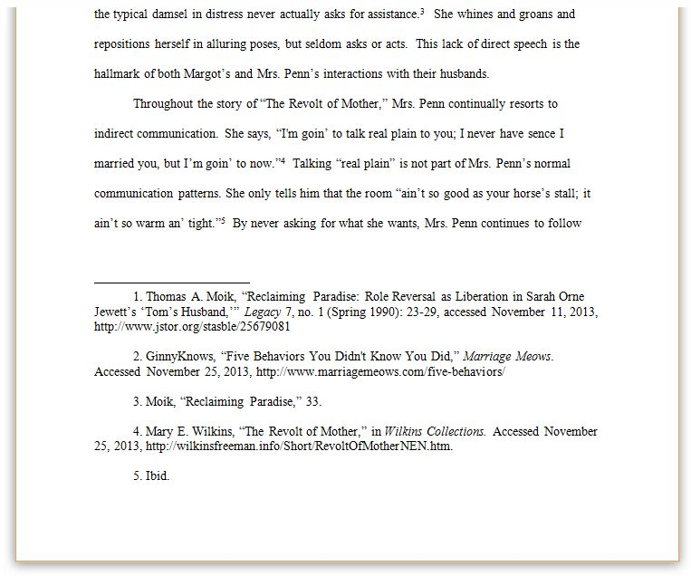“References” tab. A correlating number will automatically appear at the bottom of page (footnote) or end of document (endnote).

Formatting Notes
The note space should be single-spaced, size 12 Times New Roman. Double space between entries. Be sure to make the number a normal size by highlighting it and pressing .
Indent the first line of the entry.

Block Quotes
For quotes that are five lines or longer, make the quote its own paragraph. Indent the entire paragraph ½ inch from the left margin, omit the quote marks, single-space
it, and insert the foot/endnote number after the end period.

Repeating Footnotes
The first time you cite a source, give the full reference (see Table 2). The second time, only give the author’s last name, the article name, and the page number separated by commas.

If citing the same source twice in a row, simply put “Ibid.” followed by a comma and page number if applicable (i.e. Ibid., 45)
Writing Center

Headings
You will normally only use Level 1 headings to mark different sections. However, you can also create subsections for a Level 1 heading by using Level 2. Level 3 creates subsections for a Level 2. Never add space before or after headings.
Level 1: Centered, bold | Literary Movements
Level 2: Centered, unformatted | The Postmodern Age
Level 3: Left-aligned, bold or italicized | Postmodern Writer, Paul Auster

Bibliography and Notes

The bibliography should start on a new page at the end of your document. Make it single-spaced with a double space between each entry. Create a hanging indent (see “Working with Word” handout) and alphabetize by the first word of each entry.
Center titles | Bibliography | Notes
CD song | Bach, Johann Sebastian. "Sanctus." Mass in B Minor, BWV 232. Conducted by Herbert von Karajan. Performed by Heinz Rehfuss. London Philharmonia Orchestra. Reference Records. CD. 2000. | 1. Johann Sebastian Bach, "Sanctus," Mass in B Minor BWV 232, conducted by Herbert von Karajan, performed by Heinz Rehfuss, London Philharmonia Orchestra, Reference Records, CD, 2000.
Web page | CDC. “Marriage and divorce.” FastStats. Last modified April 24, 2013. http://www.cdc.gov/nchs/fastats.htm. | 2. CDC, “Marriage and divorce,” FastStats, last modified April 24, 2013, http://www.cdc.gov/ nchs/fastats.htm.
Web page, no date | Diersman, Angie. “How to Make Creative Hardware Menorahs.” eHow. Accessed November 21, 2013. http://www.ehow.com/how_7664658_make-creative-hardware-menorahs.html. | 3. Angie Diersman, “How to Make Creative Hardware Menorahs,” eHow, accessed November 21, 2013, http://www.ehow.com/how_7664658_make-creative-hardware-menorahs.html.
Web page, no author | “Existentialism.” The Literature Network. Accessed November 21, 2013. http://www.online-literature.com/periods/existentialism.php. | 4. “Existentialism,” The Literature Network, accessed November 21, 2013, http://www.online-literature.com/periods/existentialism.php.
Printed book | Hemingway, Earnest Miller. For Whom the Bell Tolls. New York: Harper Collins, 1936. | 5. Earnest Miller Hemingway, For Whom the Bell Tolls (New York: Harper Collins, 1936), 176.
Dictionary | Oxford English Dictionary. S.v. “hysteric, adj. and n.” | 4. Oxford English Dictionary, s.v. “hysteric, adj. and n.”
Scholarly journal,  two authors | Moik, Thomas A., and John Farnsworth. “Reclaiming Paradise: Role Reversal as Liberation in Sarah Orne Jewett’s ‘Tom’s Husband.’” Legacy, 7, no.1 (Spring 1990): 23-9. Accessed November 21, 2013. http://www.jstor.org/stable/19202039. | 5. Thomas A. Moik and John Farnsworth, “Reclaiming Paradise: Role Reversal as Liberation in Sarah Orne Jewett’s ‘Tom’s Husband,’” Legacy, 7, no.1 (Spring 1990): 23-9, accessed November 21, 2013, http://www.jstor.org/stable/19202039.
Scholarly journal, more than four authors | Pike, Leonardo, John Farnsworth, Richard Emeron, Charles Willardson, and Linda Carter. “Role Change.” Annual Review of Sociology, 16 (1990): 87-110. Accessed November 21, 2013. http://www.ebsco.org/stable/1920930 | 6. Leonardo Pike et al., “Role Change,” Annual Review of Sociology, 16 (1990): 87-110, accessed November 21, 2013, http://www.ebsco.org/stable/1920930
Article in an anthology | Roethke, Theodore. “Root Cellar.” In The Bedford Introduction to Literature. 2nd ed., edited by Michael Meyer, 548-549. Boston: Bedford Books, 1990. | 7. Theodore Roethke, “Root Cellar,” in The Bedford Introduction to Literature, 2nd ed., ed. Michael Meyer (Boston: Bedford Books, 1990), 545.
Online newspaper article | Rosenberg, Tina. “To Fight Obesity, a Carrot, and a Stick.” New York Times, November 16, 2013. http://opinionator.blogs.nytimes.com/2013/11/16/to-fight-obesity-a-carrot-and-a-stick/?_r=0 | 8. Tina Rosenberg, “To Fight Obesity, a Carrot, and a Stick,” New York Times, November 16, 2013, http://opinionator.blogs.nytimes.com/2013/11/16/to-fight-obesity-a-carrot-and-a-stick/?_r=0
If your professor requests endnotes rather than footnotes, include them as their own page before the bibliography, and list them in the same order you would have put footnotes. This means you will have repeats and “Ibid.” entries.

Note: The bibliography and notes are formatted similarly; just use periods for bibliography and commas for notes. Also, the notes format can be used as a template for end or foot notes.

